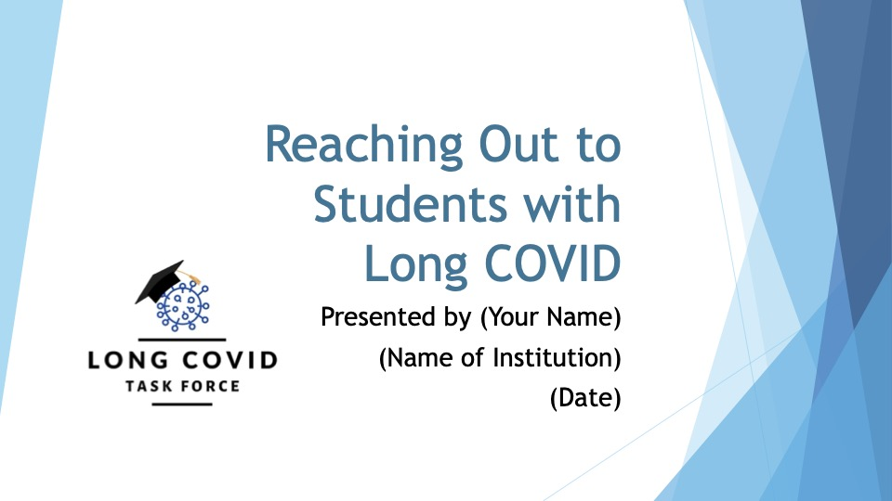

Companion Guide
For Use of the PPT

To: The Higher Education Disability Services Community (and friends!)
From: The Long COVID Task Force

During the last few months, there have been an increasing number of studies and articles in the popular press discussing the significant impact that Long COVID symptomology may have on those dealing with the aftereffects of their COVID-19 diagnosis. Current available information from the CDC suggests that as many as one-in-five individuals diagnosed with COVID may have lingering difficulties. More than a year ago, the Department of Justice and DeptED made it clear that those experiencing substantial limitations as a function of Long COVID were to be considered to be disabled and, thus, protected under Section 504 and the ADA. But while WE understand the importance of this issue, the general higher education community hasn’t grasped its urgency.

We don’t expect that disability services offices will be overrun with students requesting support/accommodations because of Long COVID. On most campuses it will likely be a limited number. But it won’t even be that, unless we help others on campus recognize these students are there, and that perhaps we can help them.

There has been very little discussion of students with Long COVID in higher ed circles, to date, and when it IS mentioned, it is generally in the context of the increased incidence of mental health issues or the physical (health-related) consequences of COVID-19. If students are experiencing Long COVID symptoms impacting on either of those areas, chances are they may also be experiencing some impact on their academic pursuits. But there has been little talk of getting referrals from the counseling center (or whether they are aware that the student had COVID if they haven’t included it in their intake), or from the health center. Faculty have even less information to work from, although they may be the first ones to notice (or hear from students) about academic struggles that may be a function of Long COVID. The more subtle (but well-documented) problems of brain fog, unexplained tiredness or fatigue, and deterioration of performance across time/effort may first be noticed by tutors or Res Life personnel. We want to reach out to all of them in the coming months.

To begin that outreach, we have created a PowerPoint (ppt) presentation that you may find useful in reaching out to your staff and faculty colleagues as the new school year begins. We wanted to share how/why the ppt was constructed as it is, and then share some ideas as to how you may be able to use it, in whole or in part, for your own purposes.

There are 36 slides in the ppt. Some of them have places for you to personalize with information unique to you/your campus (Slides #1, 6, 16, 18, 36). In some cases, there are alternative slides offered, depending on your institution and your audience. For instance, #7 is worded in a way that seems most appropriate for large institutions and for urban institutions. Slide #8 conveys the same idea, but is worded in a way that might be more appropriate to community colleges or more rural institutions. Slide #17 is directed to an audience of faculty. Slide #18 is directed to an audience that includes Counseling Center/Support Staff. Slide #19 is directed to faculty and academic support staff. You can choose to include, or remove, slides from what is here based on the audience.

The slide deck, as shared here, could likely be presented in 15-20 minutes, depending upon how much conversation ensues around a given slide. Our original idea was to give disability service providers a resource they could adapt to their own settings – a starting point – to make presentations to returning faculty and staff at the beginning of the new school year. That presupposes, however, that your institution brings together large numbers of faculty/staff at the start of the academic year. That happens at some campuses, but certainly not all. So we ALSO wanted to provide some ideas for alternate ways to use the ppt to reach out within your campus community.

After pulling together this ppt presentation, we circulated it to the members of the Long COVID task force and asked for their ideas, and their input, as to how they might use it on their campus. What follows is simply a sharing of their thoughts, in no particular order, for you to consider as you prepare to introduce the topic of students with Long COVID on your campus…

Thoughts on Use of this PPT
(from members of the Long COVID Task Force)

I was invited to speak to a group about what the impact of Long COVID might be on testing, how to document the disabling impact of Long COVID for test-takers, and why accommodations might be assigned. I used the first 15 slides to introduce the audience to general information about the prevalence and impact of Long COVID, then turned off the projector and switched to talking to them about the subject requested. The formal, “fancy” presentation at the beginning set a very professional tone for what ended with a much more casual discussion of pertinent issues.
-----

I firmly believe that the old adage “it takes a village…” applies in the instance of Long COVID. It takes the entire college community to support students, faculty, and staff experiencing symptoms of Long COVID. I thought of three main areas that I wanted to target that would encompass the entire college.

Student support services:
A group presentation of the PowerPoint to advisors, navigators, tutors, and student engagement office personnel, along with guidance on where to direct students.

Faculty:
Present the Power Point to the faculty and engage them in a discussion of what they have been observing and experiencing on their end. Work with faculty to build supports into their classrooms/teaching methods to assist all students. I’d like to do small group presentations with each various academic area separately, to tailor the presentation to what they have been observing. I would want to provide clear guidelines as to how and where to refer students experiencing symptoms.

Higher ups:
I would want to do a condensed presentation of symptoms with a synopsis of what the Office of Accommodative Services is observing with students and how this information can also apply to their faculty and staff. Make it clear that students experiencing symptomology can be sent to our office, while staff/faculty experiencing these symptoms should be guided to HR.

I would like to narrate the Power Point and make it available on a shared drive for all employees to access.
-----
I really like the format of the PPT, especially the “more generic” approach that I can tailor to meet the needs of my audience. Since I’ll be presenting to staff and faculty at our community college, I see presenting not only to faculty at their “Lunch and Learn” session in September, I’ll also offer it as a webinar to Advising and Student Life!
-----

This ppt seems heavy on the text side. I would probably want to add in some graphics and pictures to break up the presentation a little.

We have a center for teaching excellence on campus, and I would want to have a discussion with them about what they are already doing, and how they might use this if it would be useful to them. I suspect they probably already have something in the works. I would also reach out to campus marketing folks for branding and support, and then enlist all the campus partners mentioned above in disseminating word of the resource.

My campus has a Long COVID Clinic, as well as a Student Health Service, and I would want/need to collaborate with them before making such a presentation to campus groups.

I would also request a brief timeslot on the agenda of one of the Fall faculty governance meetings in order to draw attention to this, with links to resources for how to accommodate and teaching solutions on campus.
-----

- On our campus, we have not been experiencing the sort of influx with Long COVID that others have. We are a smaller rural campus, although students come from all over the US, etc. Sharing with our Student Care and Outreach team, as well as Advising and Learning Assistance (tutoring) would be natural choices – framing as “here’s something to be aware of, looking for, etc. I haven’t spoken with Counseling folks about this yet, but they and Health Services would be a natural extension of the list. Student Life, leadership, etc. would be also prime targets in my view, as well as any other student-centered office.

- I’m wondering how to relay this to graduate faculty/staff folks. Would it need to be modified to address special needs of health sciences students, law school students, etc?

- I do like the idea of having it in different formats – it would be great to have similar information to post on websites, etc.
-----

I am planning to do a "Lunch and Learn" or two for faculty and staff during the fall semester with some smaller "open house" Q&A sessions sprinkled throughout the semester. My ability to do outreach at my home campus is pretty solid, but I would also like to take this opportunity to have the faculty get accustomed to seeing the faces of the other disability service providers as our four colleges become one college. I need to do some strategic planning with them about how they would like to approach that, but it is an opportunity that is too good to be missed.
-----

I am on a very large campus where is it unlikely that I can get a sizeable audience all in one place at one time to listen to a presentation of my choosing. I think I will probably use the ppt to create and record a narrated (video) ppt presentation, post it to my website, and then do a great deal of publicity on campus to let folks know it is there and available. The availability of the generic presentation may open the doors for me to reach out to key Department Chairs and administrators, get them to view the ppt, and wrangle an invitation to come and speak at a departmental meeting.
-----

This ppt is intended as a tool for you to use as you consider how best to begin outreach to faculty and staff colleagues on your campus. You have our permission to use (or discard!) these slides in any way that works for you. If you think it lends credibility to your presentation, you are welcome to use the ppt with the Task Force logo included. If you think it is politically advantageous on your campus for the information to come from YOU (as opposed to some outside entity), feel free to remove the logo. Use the slides that work for you, eliminate the ones that don’t, and add your own in, as you see fit.

We hope you find this useful…and would love to hear from you HOW you used it, if you would care to share.
Long COVID Task Force
longcovidtaskforce@aol.com

