ONLINE PROFESSIONAL DEVELOPMENT
FROM DAIS
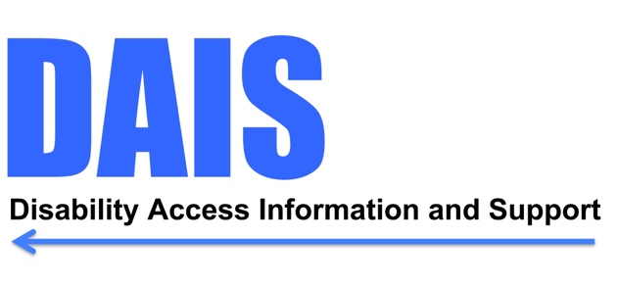
COURSE
CATALOG

FALL, 2023

All courses taught/facilitated by
Jane E. Jarrow Ph.D.
Disability Access Information and Support

Page 2 - PREFACE

Page 3 – WHAT’S IT ALL ABOUT? A BEGINNER’S GUIDE TO DSS

Page 4 – TRADING SPACES

Page 5 – SURRENDERING THE REINS

Page 6 – WHY DO WE DO WHAT WE DO? HOLDING FIRM TO
OUR FOUNDATION

Page 7 – HOW TO “JUST SAY NO!”

Page 8 – (RESOURCE) POLICY PRIMER: ANIMALS ON CAMPUS

Page 9 – REGISTRATION

(PREFACE)
ONLINE PROFESSIONAL DEVELOPMENT
FROM Jane Jarrow, at DAIS
FALL, 2023

Welcome to the course catalog for professional development classes from DAIS for the Fall, 2023. What you have on your screen is a single document that includes the titles, dates, and descriptions of all the classes to be offered by DAIS in the coming months. These classes are targeted toward folks who have responsibilities for/to/with students with disabilities in higher education – either directly or indirectly! Because of the format in which the classes are offered (described below), any and all are welcome to participate. So whether folks are looking to actively participate or just to lurk and listen in on our discussions, all institutional personnel can be included. First, let’s talk about the basics – WHAT, HOW, and HOW MUCH!!!

How Do the Classes Work?
Like all recent offerings from DAIS, these classes will be conducted solely through a private class listserv. There is no synchronous component, no obligation to participate at a certain time, or for a given length of time. In fact, you don’t have to actively participate (that is, add your comments to the discussion) if you would rather not. Lurkers are welcome here. Generally, each morning you will receive a “lesson”, delivered through the class listserv, along with prompts for some discussion questions that might be of interest regarding the day’s content. The lessons will provide both information/explanation and a wealth of online resources to explore at your leisure. AN ADDED OPTION/BENEFIT! The main lessons each morning will be accompanied by an mp3 file that you can use to supplement or complement your reading of the information. Some folks prefer to read, some prefer to listen, some do both at once. The choice is yours!

A Word About Tuition Costs
For most of the classes, the tuition fee works out to less than $50/week for instruction. Keep in mind that this includes the “added value” of letting everyone from your institution who wants to come along sign on with you for that one-time payment of tuition (that is, if there are two of you who want to sit in on a class with a tuition of $200, both get to sit in for $200. If there are 10 of you, you all get to sit in for a single $200 payment!). In other words, the tuition is not for an individual, but for an institutional contingent, no matter how large or small.
Then, too, professional development handled in this online manner saves a great deal of money/resources over more traditional forms of inservice training. You never have to leave your campus (saving both travel/per diem expenses and time), and you get to fit your class participation into your schedule, instead of trying to juggle job responsibilities around your classes.
I am a staunch supporter of AHEAD. I think everyone who works in the field of disability services in higher education should be a member of AHEAD, both because the association represents our interests to the larger world of higher education (and beyond!), and because the information, educational opportunities, and communications from AHEAD are vital to keeping abreast of important developments that impact day-to-day activities. That is why I give a 10% discount on MY classes for anyone who is a member of AHEAD. I want to encourage folks to start there, and then come to me for supplementary information.

I hope you like what you see here, and I hope you will join me for any part of it that sparks your interest – or fulfills your needs! It is going to be a busy Fall.

Sincerely,
Janie

Jane E. Jarrow, Ph.D.
Disability Access Information and Support

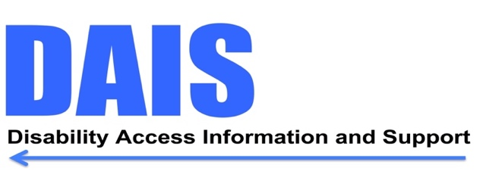

WHAT'S IT ALL ABOUT?
A Beginner's Guide to DSS
August 21 – October 6

Do you have one or more new hires on staff -- or are YOU the "new kid on the block"? Whether it is someone who is new to the field of DSS, or simply new to your institution, you will want to get them up to speed as quickly as possible. You need to make sure they have a basic understanding of the laws, the population, the general responsibilities - THE JOB - so that you can build on that to teach them how you interpret/implement all those tasks in your program.
DO YOU TRUST ME???
I hope the answer is “YES!” I can provide your new staff members with an in-depth and working knowledge/understanding of what the world of disability services in higher education is all about. After all these years, all these presentations, all these thousands of listserv posts, I think I have a comprehensive understanding of what information folks need to get started. I am willing to share - but it'll cost you!
Like the other online classes from DAIS, the class will be conducted through a private listserv, so there is no special equipment and no required time frame for participation. All folks will need is a computer, an email address, and the will to get introduced to a whole lot of information in a relatively short period of time. Topics will include:
* philosophical perspectives that shape our practice
* legal issues
* the population served (who they are, what they need)
* basic services (note takers, adaptive testing, interpreters, transportation, and much more)
* finding resources both in and outside the institution
* how the pandemic and the social upheaval of the last few years have changed our perspective and practice
* hot topics (including documentation, service animals/ESAs, online accommodations
...and more!!!
I have pulled out a number of supplementary readings to accompany the training -- and I continue to sort through my personal archives, looking for more. Moreover, I encourage the supervisors of these new hires to "listen in" on our discussion (that is, sign on to the private listserv at no additional tuition cost), so that they have a better idea of what kind of information their new employee has been exposed to, in hopes that it will provide a starting point for bringing the discussion down to campus policies/and procedures.

TUITION: $350
Trading Spaces: The Same,
But NOT The Same
August 28 – September 15

We have all seen the advertisements of open positions in our field, and we have talked about how best to orient newcomers to the laws, the practices, and the mission of disability service providers in higher education. But not all of those positions will be filled by folks coming into the field. Some will be filled by folks who have experience in disability services in higher education. Some are moving up. Some are moving over!

Some of those taking new positions will be moving into positions of authority, either in the program they have been serving, or at another institution. Some will be working in much the same position, but in a new locale with a different institutional profile, a different student population, and (possibly) a different way of doing things. It can be a disorienting, frustrating, and potentially dangerous time.

It can be disorienting for those who have been doing this work for some time to recognize that there is very little in our world that is set in stone, and that the way you have been carrying out the work – successfully – for some time is not the way things are done in this new setting. Which way is right… what you know, or what you are being introduced to? The answer is that they are likely BOTH right. You just need to reconcile what you knew (or thought you knew!), with what is expected of you now. Then, again, you may find that they are doing things in a much better way than what you did in the old setting, or using new/different technology, or doing something exciting that you never saw done before. All good things – but, still, disorienting.

It can be frustrating because there will be practices and policies that you followed in your former position that were really good – and that are not being followed at all, or are being handled differently, in this new setting. You may SO want to explain to your new colleagues that you know a different/better way to do something, or that they are missing a great opportunity by not ______. But is it your place to make such pronouncements? It can be frustrating because no one is explaining why or how certain things are done – you are simply expected to know and understand – and you are never quite sure if you are doing things right.

And it can be dangerous because, as the saying goes, “you only get one chance to make a good first impression.” For disability service providers who are trading places, that first impression may not be a first meeting, so much as a first semester. How things go during your first few months on the job can set the stage for how you will be received and supported throughout your tenure in this new position. You want to get it right – from the start!

Let’s spend a couple weeks together, talking about how best to balance what you had, then, with where you are now. We’ll talk about the school, the department, the policies and practices, your new colleagues, the changes in student demographics – all the things that are new and should provide you with a wealth of new and exciting opportunities.

“And suddenly you know it is time to start something new, and trust the magic of beginnings!

TUITION: $100
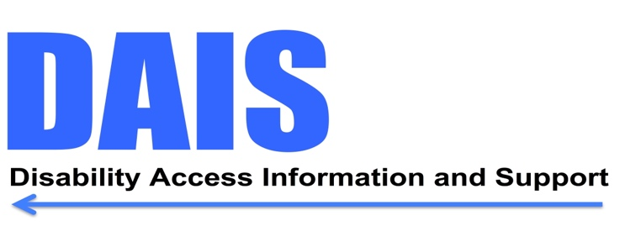
Surrendering the Reins:
Leaving a Strong Program
With a Clear Conscience
August 28 – September 15

You have been the Director of the disability services program at your institution for several/many/a-whole-lot (!) of years. The number of students with disabilities served through your office has grown significantly. So have the demands for ESAs and single rooms! Students are using technology regularly these days that hadn’t been invented when you began your journey. You shepherded your program through the pandemic, supporting students with disabilities through this unprecedented time in our history. And now it’s time to leave. Some may be leaving one program to move to another at a new location. Some will be retiring, and are looking forward to have time to do what they choose to do, whether personally or professionally. Either way, you want to be sure that the strong program you have built over all those years will remain – and STAY strong – when you leave.

I knew a disability service provider who was working in a small, private liberal arts institution in the late 70’s, when the Section 504 regulations were implemented. She stepped up to meet the challenge and the need, creating a comprehensive support program for students with disabilities at the institution. At some point, she realized that the program worked so well because she carried not only the institutional memory, but the respect and trust of so many at the institution. And she worried that if she left, whomever came after her would not find the same receptiveness. This service provider worked until she was 82, because she was afraid to retire. She was afraid that if she walked out the door, they would dismantle the program behind her and replace it with a scaled-down version of what she had worked so hard to build, because she wouldn’t be there to defend it.

You don’t want to work until you are 82. But you don’t want to leave your program, the institution, and the students who have been served there in a state of limbo because you aren’t there to guide things. So why not create a planned, orderly, and comprehensive exit strategy? Use the time to consider the active steps you can take to prepare for your departure:

- It’s time to review your existing policies and procedures – and to document WHY those policies and procedures are established that way. What kind of documentation can/should you create to leave for your successor that will help them understand past institutional experience that led to current institutional practice?
- Take a look at your job description – the one that the folks in HR will put out when it is time to look for your replacement. Is it a good reflection of the job you really do – and that the institution NEEDS their Director to do? Now would be a good time to work through channels to get them to clarify, correct, or enhance that job description so that they are looking for candidates who have the skills needed.
- How much can/should you be involved in the process of looking for your replacement, and how much can/should you be involved in the transition when the time comes? Think about what you want the answer to be – and think about how to make your case for why you think you can/should help before the institutional powers-that-be get ready to begin the search.
- What about your team? Are there things you can do to help them prepare for a change in leadership? Are there things you can do to smooth the way for your successor, so that your staff doesn’t feel they are being disloyal to you in welcoming someone new in your position?

If you foresee leaving your current position in the next year or so, now is a good time to start thinking about how best to make a graceful exit. Why not take a few weeks to talk it through with colleagues who are in the same position, asking the same questions!

TUITION: $100
Why Do We Do What We Do?
Building On a Firm Foundation
September 18th – October 20th

Lately, our professional listserv traffic is full of examples of folks who understand the theory of our work… but seem a little weak on the execution! We all know that our goal is to provide equal access to educational opportunity for students with disabilities. But some seem to be struggling with what “equal access” really means. They worry that in order to have equal access, students with disabilities should find those opportunities equally convenient, despite the realities of their disability. Instead of working to minimize the impact of the disability on opportunity, they find themselves trying to lessen the disadvantages created by the disability in the student’s life. That’s not our job!

This class will focus on WHY we provide accommodations for students with disabilities, and HOW we determine whether the requested accommodation is truly providing access for the student with a disability… or something else. Along the way, we will take time to discuss the (legendary!) interactive process – what it is, and what it ISN’T. Too many folks believe that the purpose of the interactive process is to negotiate an appropriate (and mutually agreeable) solution. That isn’t true. Your obligation is to listen to what the student has to say/suggest on the subject, not to meet them in the middle.

Our role is to determine if this is a student with a disability (a physical or mental impairment that substantially limits one or more major life activities); determine what functional limitations are created by the student’s disability (a term that is too often misapplied!); determine what, IF ANY, accommodation is needed to mitigate the impact of those functional limitations; and, determine if the accommodation identified to mitigate the impact of the functional limitation is reasonable.

We do our institutions, our students, and our credibility real damage when we trivialize the status of being a person with a disability by looking for ways to bring everyone who asks under the umbrella of protection, or assume that every difficulty experienced by a student with a disability is related to their disability (and not just related to being a student), or assign accommodations simply because we want to help the student, or because we don’t think the rules are really important

Disabled students are as capable as their nondisabled peers, and can and should be treated as students at the institution who happen to have disabilities, instead of as a separate category of participants in institutional programming. We create a second-class citizenry when we choose to focus and respond to the disabled students’ weaknesses, instead of their strengths. Let’s stop doing that.

We all believe that all students should have equal opportunity. The problem is, we haven’t been treating all students equally. Let’s take some time to revisit the mission of disability services and discuss how to use that continuing mission to guide our programs and practices.

TUITION: $200

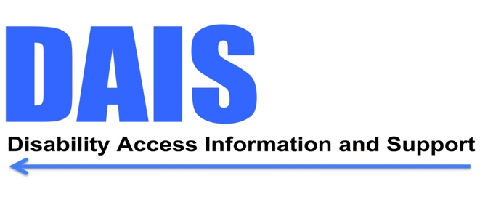

How to “Just Say NO!”
October 23rd – November 17th

I have heard it said that when it comes to accommodation requests, you should “say ‘yes’ when you can, and ‘no’ when you must.” I don’t think I agree. My version would be, “say ‘yes’ when you can, and ‘no’ when you should.”

If your focus is on saying “yes” whenever possible, it seems to me you will say “yes” a whole lot of the time. Saying “yes” is easy. Nobody (except MAYBE faculty) grumbles when you say “yes” to an accommodation request. Not the student, not the parent, not the administrators. But “yes” isn’t always the appropriate answer. There are times when you SHOULD say “no.”

No matter what philosophy underlies your practice in disability services (Social Justice? Civil Rights? Universal Design? Whatever!), there will come a time when you need/want/must say “no.” That’s not always easy. Over time, we’ve shared lots of advice with one another about whether or not to grant an accommodation – not so much on how to politely, gracefully, and firmly say “no” when the answer should be “no.”

It seems even harder these days. Suddenly, saying “no” has taken on a whole new dimension. When we turned down a request for extended time for a student who presented “iffy” documentation of ADHD, no one suggested that we were going to scar the kid for life in the process. When we refused a course substitution for math for the student who was blind, no one told us that his eyesight would get worse because of that decision. But service providers who turn down a request from a student with a mental health diagnosis for a single room, or to be allowed to turn off the camera in a remote class, or for attendance leniency, are suddenly being presented with documentation that suggests (sometimes subtly and sometimes directly!) that if you don’t grant the accommodation the student’s mental health problems will worsen and it’ll be your fault!

This class is all about how to say “no” (when you should/must). We will talk about:
* WHY it is important to say “no” at times
* WHY it is hard to say “no” (from not wanting to disappoint, to wanting to avoid confrontation, to lack of administrative support, and more)
* HOW to say “no” in different circumstances (explaining the same “no” answer to students, faculty, and administrators)
* WHAT is/isn’t relevant in deciding to say “no”
* WHAT problems are created when you say too much or too little in your refusal
And more…

We will take the time to review some case studies along the way, discussing what was said (and why), how it was received, and what happened as a result.

Whether you are a newcomer to the field or an old-timer at this game, it is good to remember that saying “no” doesn’t make you a bad person – and, at times, it may make you a better service provider. Perhaps being reminded of that in the company of colleagues who share your struggle and hesitation will help to fortify you to say “no” when you should.

TUITION: $200

Policy Primer: Animals on Campus
A New Resource from DAIS

For more than a decade, I have been offering an increasingly expanded class regarding animals (ESAs and service animals) on campus. The most recent iteration of the class is a six-week course titled, “Fantastic Beasts and Where NOT to Find Them.” I have offered it twice a year, spring and fall, for the last several years. Until now.

I truly believe that folks need a firm (and full!) grounding in everything from the laws that govern animals on campus to the ever-changing practical considerations in managing their presence. I will continue to offer the full class, covering all that information and those nuances, this spring. For now, however, I have created a resource with a much more limited scope. It doesn’t tell you all that I think you should know, but it DOES cover what most folks want to know – what should we have in our policies and procedures to guide our response to animals on campus?

This Policy Primer provides model statements that can be used to build your ESA and Service Animal policies. It does NOT provide a single format for folks to pick up, in total, add their office contact info at the top and bottom, and wash their hands of the task. I am going to make you work for it. I’ll give you specific recommendations for policy points, suggested language, and the reason why those suggestions are made. But you’ll need to pick and choose – and massage – the pieces you choose to use, based on the realities of your institutional situation, the policies/procedures currently in place, and your philosophical orientation toward the issues at hand.

The Primer will provide direction in developing a service animal policy and an ESA policy (including language to be incorporated into your general housing accommodation policy). There are recommendations for language to be incorporated into ESA contracts, and restrictions to be established regarding where the ESAs can go (or not!) on campus. There are some specific suggestions for how to manage the presence of service-animals-in-training.

The Primer does NOT discuss how to separate out (or interpret) laws regarding service animals from guidance regarding ESAs, or about how to evaluate documentation submitted in support of ESAs, or how to justify the rules you are incorporating (from saying “no” to multiple animals, to restrictions on the age of animals allowed in the residence hall, to excluding exotic animals). For all those issues, you will need to take the full course in the Spring.

The Primer will be shared with you electronically, in both WORD and PDF format. You are free to share the document with any or all at your institution (just as you could lend a hardcopy of a book for others to peruse). It can be ordered through the same registration form used to arrange for classes from DAIS for Fall, 2023.

COST: $100
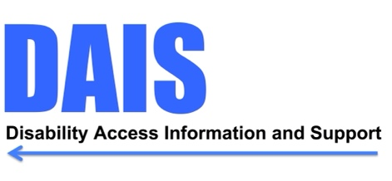
Professional Development
from DAIS - Fall, 2023

REGISTRATION INFORMATION:

Primary Contact:_____________________________________________
Address:___________________________________________________
Telephone Number:__________________________________________
Email Address:______________________________________________
Institution:___________________________________________________
Payment by: Institutional check _____ Institutional credit card _____
Personal check/credit card _____
Please calculate tuition costs on page 2
and then transfer Total Due to this line __________

Checks should be made payable to:
DAIS is a sole proprietorship.
The Tax ID # associated with any registration/payment is 348-38-2091.
DAIS
(Disability Access Information and Support)

and mailed to:
2938 Northwest Blvd.
Columbus, OH 43221-0192

If you wish to FAX a copy of the order to DAIS in order to assure your place in the class(es), to be followed by institutional payment, the FAX number is 270-477-9450.

CREDIT CARD OPTION
You can now pay for your purchase/tuition by credit card, using Mastercard or Visa (Print out, fill out, then FAX or mail the registration information above, the list of courses on page 2, AND the Credit Card form)

Professional Development Opportunities from DAIS
Please calculate the tuition to be paid at this time and transfer
“TOTAL DUE” to page 1 of registration form.)

- What’s It All About? A Beginner’s Guide to DSS
August 21 – October 6 Tuition $350

- Trading Spaces
August 28 – September 15 Tuition $100

(3) Surrendering the Reins
August 28 – September 15 Tuition $100

(4) Why Do We Do What We Do?
Holding Firm to Our Foundation
September 18 – October 20 Tuition $200

(5) How To “Just Say No!”
October 23 – November 17 Tuition $200

(RESOURCE) Policy Primer – Animals On Campus $100

YOUR cost for tuition: Please indicate the cost for those classes you are
registering for now. (Note: You will be able to register for additional classes
throughout the Fall)

# 1 What’s It All About: A Beginner’s Guide… due: _____
# 2 Trading Spaces due: _____
# 3 Surrendering the Reins due: _____
# 4 Why Do We Do What We Do?… due: _____
# 5 How To “Just Say NO!” due: _____
(Resource) Policy Primer: Animals On Campus due: _____

Total before discount ______
(10% discount for members of AHEAD/WAPED)
TOTAL DUE: ________
(transfer this amount to Page 1 of course registration)

CREDIT CARD PAYMENT INFORMATION

Name of Primary Registrant ____________________________________

Institution _____________________________________________________

E-Mail: _______________________________________________________

Street Address _________________________________________________

City, State/Province ________________________________________

Zip+4/Postal Code________

Telephone __________________ Text Telephone? Yes ____ No ____

Total Amount Owed: _______

Credit Card Type: ____ MC ____ Visa

Card Account Number:_________________________________________

Exp. Date (required)________________________ 3-digit Security Code ________

Card Holder's Signature:

(required)_________________________________________________________

Card Holder's Name as it appears on card:

__________________________________________________

FAX (270) 477-9450
or
MAIL to:
DAIS is a sole proprietorship.
The Tax ID # associated with any registration/payment is 348-38-2091.
DAIS
2938 Northwest Blvd.
Columbus, OH 43221
(270) 477-9450 (FAX)
(614) 571-5681 (V/T)

